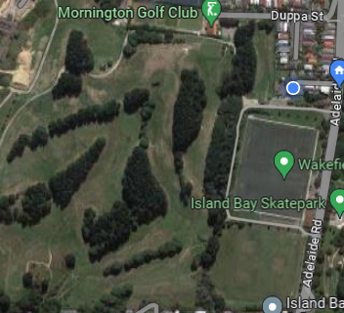
Start Finish Zone
College Sport Wellington
Secondary Schools
Cross Country Relays
Wednesday14 May 2025
COURSE MAP
Wakefield Park Grass &
Berhampore Golf Course,
Adelaide Road, Berhampore
Lap Course
Distance 2.0 km
per athlete

Sport Wellington and
Athletics Wellington event
is supported by
Victoria University of Wellington Sport
Wakefield Park Turf
Island Bay Football Clubrooms – Event Headquarters
including check-in toilets and changing rooms

